OBJECTIVE QUESTIONS

- What is the total no. of tables present in the data?

Clearly total no. of tables present in the data is two. One is present in sheet named Raw Data and second in sheet named country description.

- What is the total no. of attributes present in the data?

Clearly total no of attributes present in the data are 20.

- How many categorical columns are there in the data? [Search about categorical and continuous data, and try to answer this question]
12 categorical columns

- The data consists of some inconsistent and missing values so ensure that the data used for further analysis is cleaned.
Dataset was successfully cleaned as:
- Checked for duplicates
- Handle missing values
- Included CountryName column using VLOOKUP
- Added Year column from datekey column using LEFT function
- Added currency symbol with Average_cost_for_two in new column cost_for_two

- Using the LookUp functions, fill up the countries in the original data using the country code.
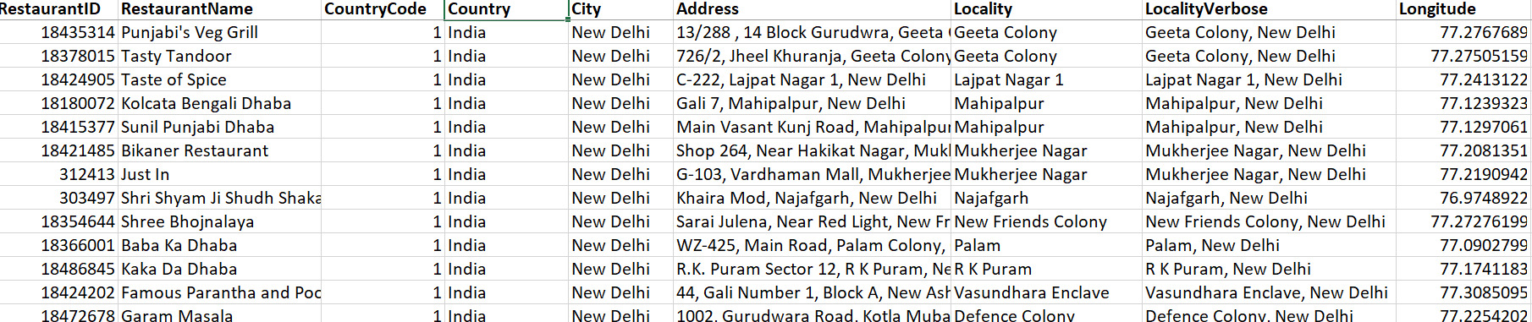

Observation:
Clearly country column was filled using VLOOKUP function as provided in table given above.

- Create a table to represent the number of restaurants opened in each country.

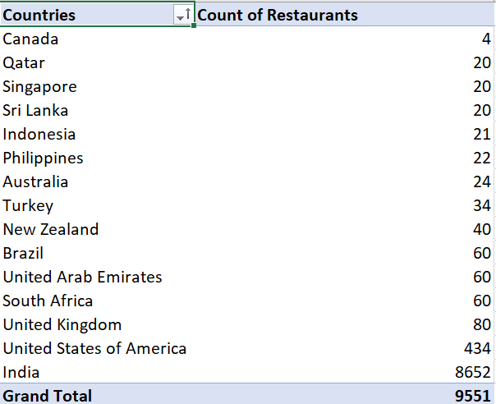
Observation:
Clearly table given above provides with total number of restaurants present in each country. India has maximum and Canada is having minimum.
- Also, the management wants to look at the number of restaurants opened each year, so provide them with something here.

Observation:
Clearly chart given above provides number of restaurants opened in particular year. Year 2011 had maximum openings.

- What is the total number of restaurants in India in the price range of 4?
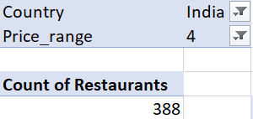

Observation:
Total number of restaurants in India in the price range of 4 is 388 as provided in table above.

- What is the average number of voters for the restaurants in each country according to the data?

Observation:
Clearly chart given above provides average number of voters in different countries. Indonesia on top having maximum voters and Brazil on bottom having minimum voters.

- Calculate the average rating for all the restaurants that have price_range < 4 and provide online delivery. Use only the “IF” function, Logical Operators, and Aggregation functions to solve this problem.

This formula didn’t work so I used below one

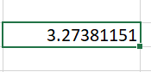

Hence average rating came out 3.27381151.

- Using Conditional formatting highlight the rows of restaurants that are located in the countries or cities that you’ve suggested to the management for opening new restaurants.

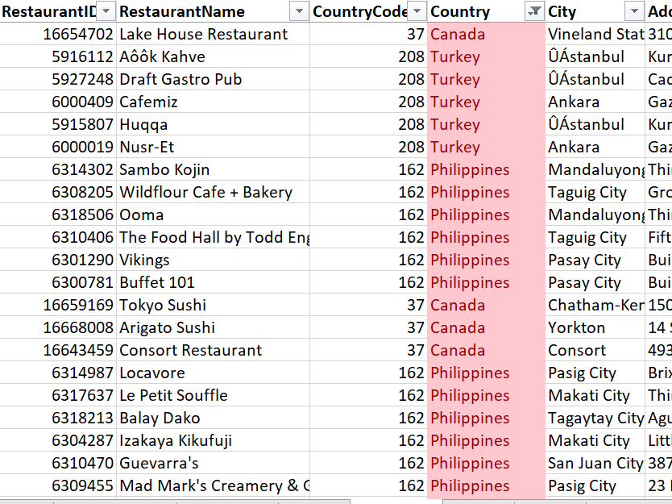

Criteria for selection:
Philippines, Indonesia and Turkey: Higher customer ratings and less competition.
Canada: Clearly number of restaurants present already are minimum so least competition.

- Create a new customized price column that consists of the abbreviation/symbol of the currency along with the Average_cost_for_two value.

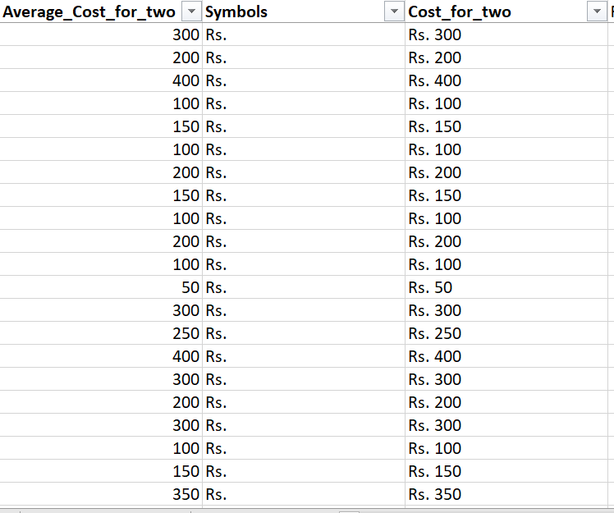

Observation:
Clearly a new column Cost_for_two is created that contains symbol of currency along with average_cost_for_two.

- How can you create an array formula in Excel or Google Sheets to count the number of restaurants listed that do not offer online delivery, are in the lowest price range, and have an average cost for two people less than or equal to 250 Indian Rupees?

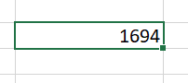
Number of restaurants came out to be 1694.

SUBJECTIVE QUESTIONS

- Suggest a few countries where the team can open newer restaurants with lesser competition. Which visualization/technique will you use here to justify the suggestions?

Countries with low restaurant numbers and high average customer ratings are ideal for launching new restaurants.

Insights:
- Number of restaurants: Indicates which country has a smaller number of restaurants.
- Ratings: Average ratings of restaurants in different countries.

Recommendations:
From the above analysis I suggest the team can open newer restaurants in Philippines, Indonesia, Turkey and Canada.
Philippines, Indonesia and Turkey: Higher customer ratings and less competition.
Canada: Clearly number of restaurants present already are minimum so least competition.

- Come up with the names of States and cities in the suggested countries suitable for opening restaurants.

Cities suitable for opening new restaurants are divided into two categories. First category is where already many restaurants present as it shows demand in those cities. Second category is where there is potential for future demand.

Insights:
Number of Restaurants: It provide us the total number of restaurants in different cities of countries suggested to open new restaurants.

Recommendations:
Clearly from the above analysis cities having most opportunity will be having the greatest number of restaurants already available because it shows the demand in those cities which are:
Jakarta (Indonesia)
Ankara and Istanbul (Turkey)
Mandaluyong and Taguig (Philippines)

Also, there are some cities which have potential for future demand which are:
Bogor, Tangerang (Indonesia)
Pasay, Pasig, Makati (Philippines)

- According to the countries you suggested, what is the current quality regarding ratings for restaurants that are open there?

Ratings of all the countries were taken and then filter was applied based on our suggested countries.

Insights:
Ratings of suggested countries: Philippines is having higher ratings of restaurants followed by Turkey, Indonesia. Canada has relatively lower ratings.

- Also, what is the current expenditure on food in the suggested countries, so we can keep our financial expenditure in control?

Expenditure on food of all the countries were taken and then filter was applied based on our suggested countries.

Insights:
Expenditure on food: Clearly Indonesia is having highest expenditure on food followed by Philippines.

- Come up with the names of restaurants from the recommended states that are our biggest competitors and also those that are rated in the lower brackets, i.e. 1-2 or 2-3

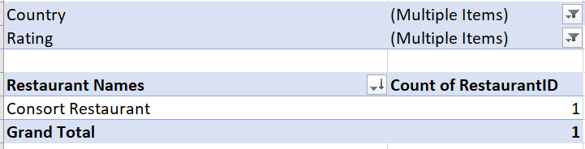

Restaurant names were taken and then filter was applied based on our suggested countries and ratings those come in lower brackets i.e., 1-2 or2-3

Insights:
From the above analysis the names of restaurants from recommended states that are biggest competitors and also those that are rated in lower brackets is Consort Restaurant.

- Which cuisines should we focus on in the newer restaurants to get better feedback? Does the choice of cuisines affect the restaurant ratings?

Average ratings of different cuisines were taken and then filter was applied based on our suggested countries.

Insights:
Ratings of cuisines: Average ratings of different cuisines are shown with help of bar chart.

Recommendations:
From the above analysis cuisines, we should focus on in newer restaurants are: Sushi Japanese, Indonesian and Filipino, Kebab and Turkish Pizza, Desserts
And yes, choice of cuisines affects the restaurant ratings.

- According to our current data, should we go for online delivery and table booking? Does that affect the customer’s ratings?

Average ratings were taken to check if having online delivery and having table booking will affect the ratings or not.

Insights:
Online delivery facility: Indicates the ratings for restaurants having online delivery facility and not.
Table booking facility: Indicates the ratings for restaurants having table booking facility or not.

Recommendations:
Clearly from the above analysis I will suggest team to go for online delivery and table booking facility in upcoming restaurants.
Yes, having online delivery and table booking facility restaurants have higher ratings as compared to those who don’t have.

- Should the team keep the rate of cuisines higher? Will that affect the feedback? According to our data are the rates of cuisines and ratings, correlated?

Prices of different cuisines and average ratings of different cuisines were taken and then scatter plot was plotted for same.

Insights:
Cuisine’s price and ratings: Indicates the relation between cuisines price and average ratings.

Recommendations:
No strong positive correlation between cuisine price and ratings. Mid-priced cuisines dominate the market and perform equally well in ratings as high-priced ones. Restaurants shouldn’t rely only on premium pricing to expect higher ratings — focus should be on taste, service, and consistency. Customers seem to value experience over cost.

- What is the distribution of the number of restaurants of different price ranges in all the countries?

All the countries were taken and number of restaurants present in different price ranges were taken.

Insights:
Restaurants in different price range: Indicates number of restaurants present in different price range in particular country. Clearly, India is having maximum followed by USA.

- Explain your approach in brief for suggesting countries/cities in order to open new restaurants, if the objective and subjective questions would have not been given to assist you. [you have to give bullet pointers in order to answer this question]

- Extract number of restaurants already present in countries and cities.

- Prioritize countries having lesser number of restaurants present already as this indicates lesser competition.

- Evaluate customer ratings based on each country.
- Prioritize countries with high customer ratings as this indicates high demand.

- Analyse average cost for two people in different countries.

- Extract cuisines and analyse which cuisine has highest ratings.

- Finally choose countries having less competition and higher customer ratings.

